June 08 Notes
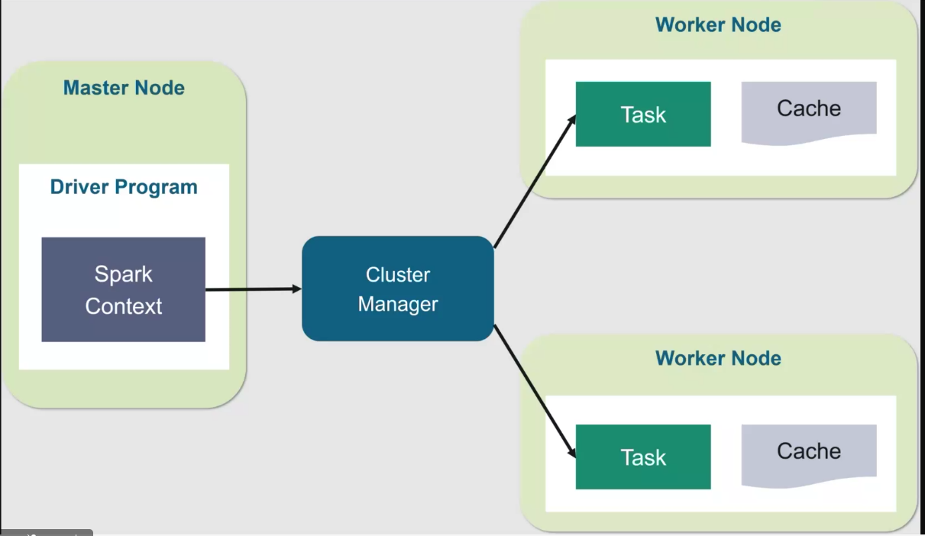

Apache Spark Cluster Architecture
Apache Spark follows a master-worker architecture for distributed data processing. The Master Node contains the Driver Program, which is responsible for controlling the execution of the application. Inside the Driver Program, the Spark Context acts as the entry point to Spark and communicates with the Cluster Manager.
The Cluster Manager is responsible for allocating resources and distributing tasks across the available worker nodes. It receives requests from the Spark Context and decides where tasks should be executed.
The Worker Nodes perform the actual computation. Each worker node executes one or more Tasks, which are small units of work created from the Spark application. Worker nodes can also use Cache Memory to store intermediate data in memory. This caching feature improves performance by reducing the need to repeatedly read data from disk.
When a Spark job is submitted, the Driver Program sends it to the Cluster Manager, which distributes the tasks among the Worker Nodes. The worker nodes process the tasks in parallel and return the results to the Driver Program. This architecture enables Spark to achieve high-speed, scalable, and fault-tolerant data processing for big data applications.
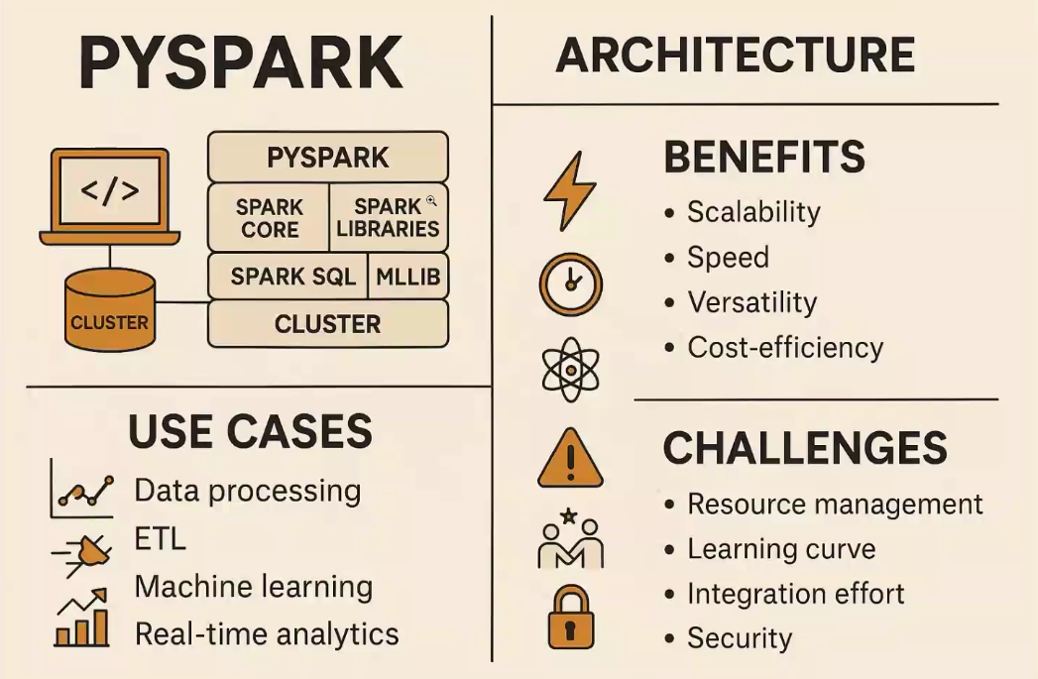

1. What is Big Data and What is PySpark?
What is Big Data?
Big Data refers to extremely large and complex datasets that cannot be processed efficiently using traditional databases and software tools.
5 V's of Big Data
- Volume – Large amount of data.
- Velocity – Speed at which data is generated.
- Variety – Different types of data (text, video, images, etc.).
- Veracity – Accuracy and quality of data.
- Value – Useful insights obtained from data.
Examples
- Social Media Data
- E-commerce Transactions
- Banking Records
- IoT Sensor Data
- Healthcare Data
What is PySpark?
PySpark is the Python API for Apache Spark.
It allows developers and data engineers to process large-scale data using Python.
Features of PySpark
- Distributed Data Processing
- Fast In-Memory Computation
- Scalable Architecture
- Fault Tolerance
- Supports SQL, Machine Learning, Streaming, and Graph Processing
Advantages
- Handles Big Data efficiently
- Faster than traditional processing
- Easy integration with Python
- Supports Data Engineering and Data Science tasks

2. Spark's Basic Architecture
Apache Spark follows a Master-Worker architecture.
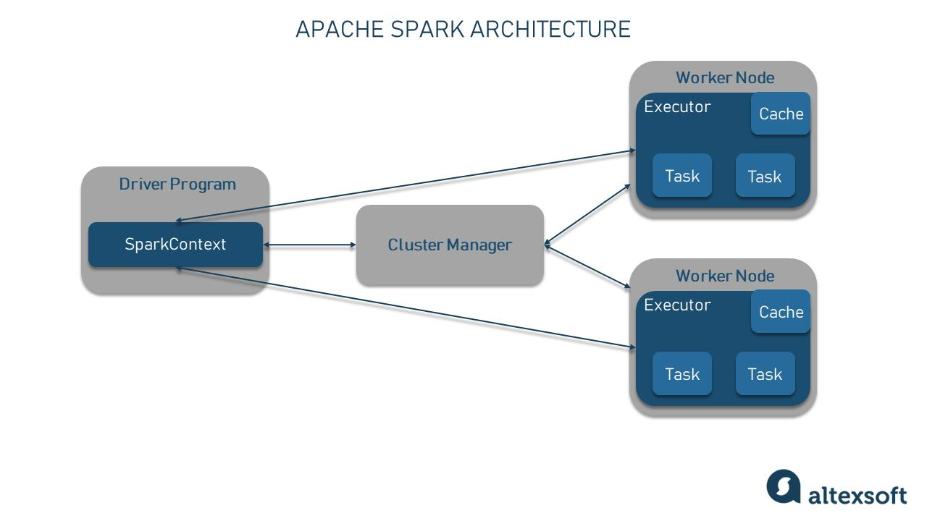
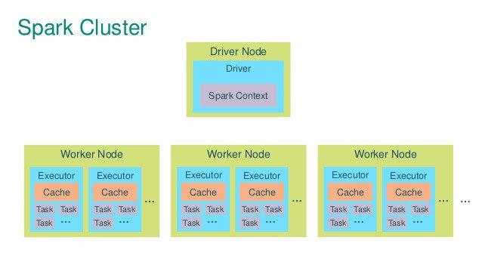
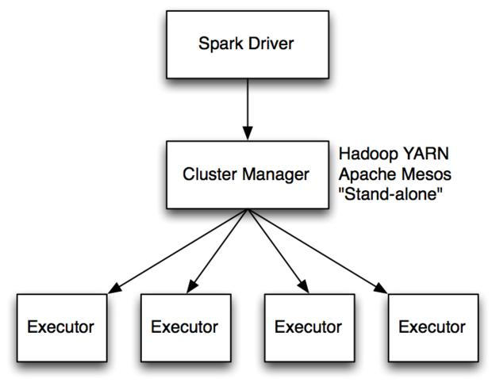

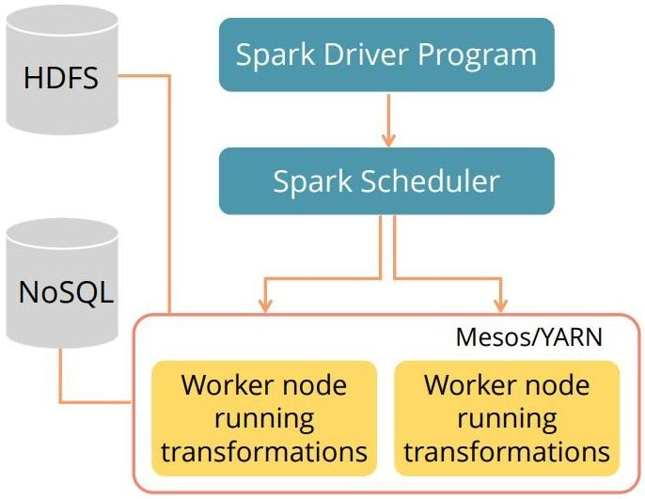
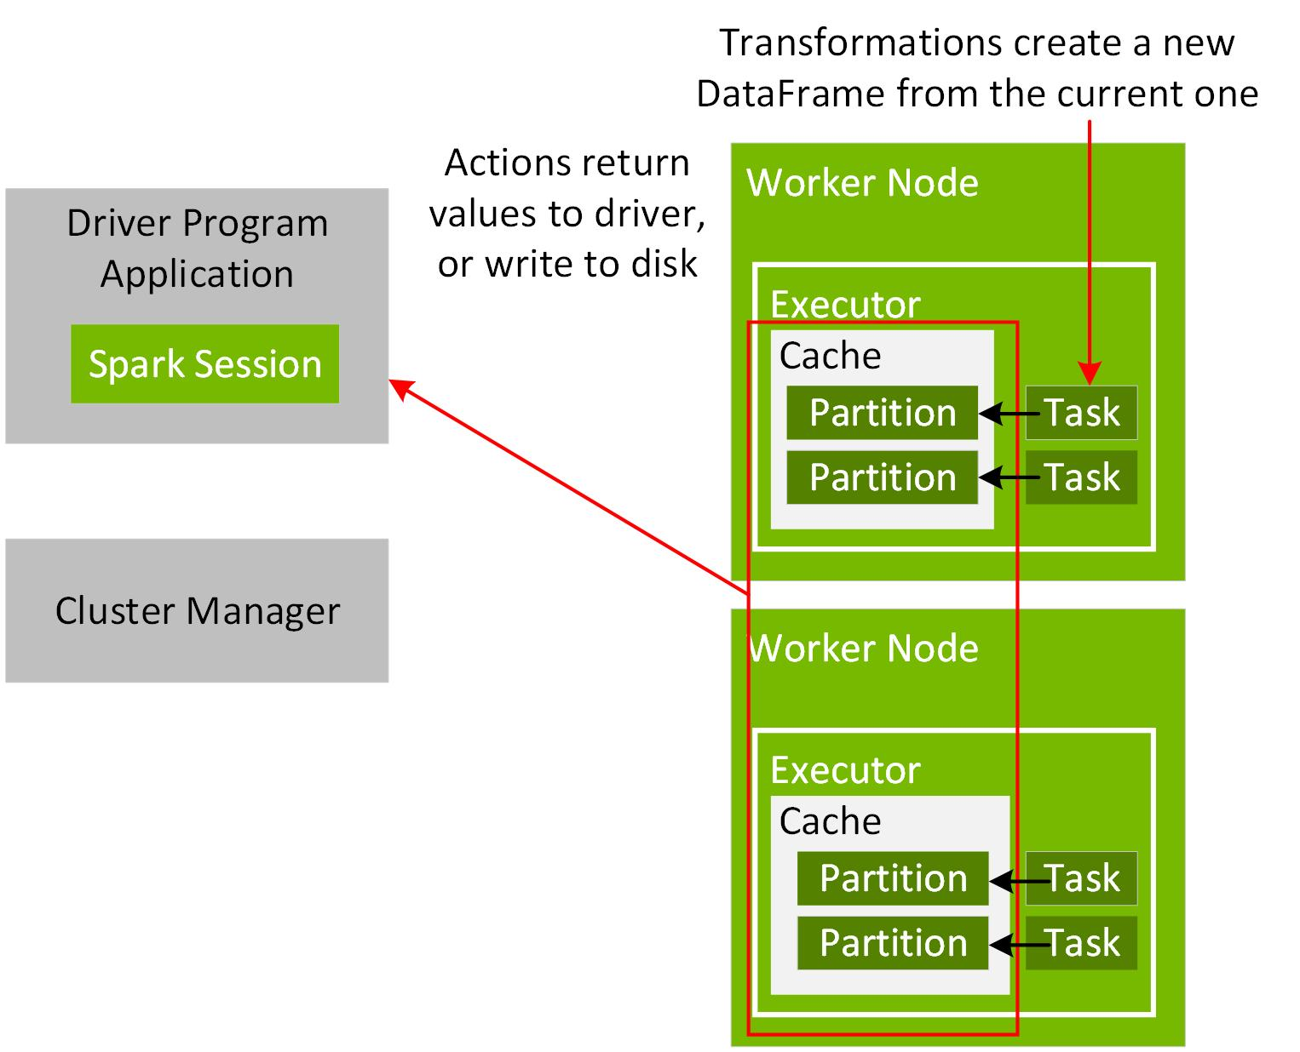

Components
Driver Program
- Main application that controls execution.
- Creates Spark Session and Spark Context.
- Sends tasks to worker nodes.
Cluster Manager
- Manages cluster resources.
- Allocates CPU and memory.
- Distributes tasks among workers.
Worker Nodes
- Machines that execute tasks.
- Store data and process computations.
Executors
- Run inside worker nodes.
- Execute tasks assigned by the driver.
Task
- Smallest unit of execution in Spark.
Working Flow
- User submits Spark application.
- Driver Program starts.
- Driver contacts Cluster Manager.
- Cluster Manager allocates resources.
- Worker Nodes execute tasks.
- Results are returned to Driver.
3. Cluster Manager, Spark Session, Spark Context, Driver Node, Worker Node
Cluster Manager
Cluster Manager is responsible for resource allocation and scheduling.
Responsibilities
- Manage cluster resources.
- Allocate executors.
- Monitor worker nodes.
Types
- Standalone Cluster Manager
- YARN
- Mesos
- Kubernetes
Spark Session
Spark Session is the entry point for all Spark applications.
Example
from pyspark.sql import SparkSession
spark = SparkSession.builder \
.appName("MyApp") \
.getOrCreate()
Functions
- Read Data
- Create DataFrames
- Execute SQL Queries
- Manage Spark Applications
Spark Context
Spark Context establishes communication between the application and Spark cluster.
Example
sc = spark.sparkContext
Responsibilities
- Connect application with cluster.
- Create RDDs.
- Manage distributed processing.
Note
Spark Session internally contains Spark Context.
Driver Node
Driver Node is the brain of the Spark application.
Responsibilities
- Executes main program.
- Creates Spark Session.
- Creates tasks.
- Schedules execution.
- Collects results.
Example
When you run:
df.show()
The Driver Node creates execution plans and sends tasks to workers.
Worker Node
Worker Nodes perform actual computation.
Responsibilities
- Execute tasks.
- Store cached data.
- Return results to Driver.
Example
If a dataset has 10 million records:
- Driver divides work into tasks.
- Worker Nodes process partitions in parallel.
4. What is Client Mode and Cluster Mode?
When running a Spark application, it can run in two deployment modes:
Client Mode
In Client Mode, the Driver Program runs on the local machine where the application is submitted.

User Machine
Driver Program
Cluster Manager
Worker Nodes
Advantages
- Easy debugging.
- Suitable for development and testing.
Disadvantages
- Driver machine must remain active.
- Network latency can affect performance.
Example
spark-submit app.py
Cluster Mode
In Cluster Mode, the Driver Program runs inside the cluster.
Architecture
User Machine
Cluster Manager
Driver Node (Inside Cluster)
Worker Nodes
Advantages
- Better performance.
- More reliable.
- Suitable for production environments.
Disadvantages
- Harder to debug compared to Client Mode.
Example
spark-submit --deploy-mode cluster app.py

1. What is RDD?
RDD (Resilient Distributed Dataset) is the fundamental data structure of Apache Spark.
It is a distributed collection of data that is stored across multiple nodes in a cluster and processed in parallel.
Key Features of RDD
- Resilient – Can recover data automatically if a node fails.
- Distributed – Data is distributed across multiple machines.
- Immutable – Once created, it cannot be modified.
- Parallel Processing – Data is processed simultaneously on multiple nodes.
- Fault Tolerant – Uses lineage information to recover lost data.
Example
from pyspark import SparkContext
sc = SparkContext("local", "RDD Example")
numbers = sc.parallelize([10, 20, 30, 40, 50])
print(numbers.collect())
Real-Life Example
Imagine a large book divided into several chapters and given to different students to read simultaneously. Each student reads a chapter and later combines the results. This is similar to how an RDD works in Spark.

2. What are the Advantages of Using RDD?
1. Fault Tolerance
RDD automatically recovers lost data using lineage information.
2. Parallel Processing
Tasks are distributed across multiple worker nodes, making processing faster.
3. Scalability
RDD can handle very large datasets spread across many machines.
4. In-Memory Computation
Data can be cached in memory, improving performance.
5. Supports Unstructured Data
RDD can process structured, semi-structured, and unstructured data.
6. Flexible Transformations
Supports operations such as:
map()
filter()
flatMap()
reduceByKey()
7. Suitable for Complex Processing
RDD provides low-level control over data processing.
Example
rdd = sc.parallelize([1,2,3,4,5])
result = rdd.map(lambda x: x * 2)
print(result.collect())
Output:
[2, 4, 6, 8, 10]
3. What is Lazy Evaluation?
Lazy Evaluation means Spark does not execute transformations immediately.
Instead, Spark records all transformations and executes them only when an Action is called.
Transformations (Lazy)
These do not execute immediately:
map()
filter()
flatMap()
distinct()
Actions (Execute the Job)
These trigger execution:
collect()
count()
take()
first()
saveAsTextFile()
Example
rdd = sc.parallelize([1,2,3,4,5])
result = rdd.map(lambda x: x * 2)
filtered = result.filter(lambda x: x > 5)
At this point, Spark does not execute anything.
When we call:
print(filtered.collect())
Spark executes all previous transformations and returns:
[6, 8, 10]
Why Lazy Evaluation?
- Improves performance.
- Optimizes execution plans.
- Reduces unnecessary computations.
- Minimizes data movement between nodes.
Workflow
RDD Creation
Transformations (map, filter, etc.)
Spark Builds DAG
Action Called (collect, count)
Job Execution
Result Returned
Summary
RDD (Resilient Distributed Dataset) is Spark's fundamental distributed data structure used for parallel processing and fault-tolerant computation.
"A fault-tolerant distributed collection of data processed in parallel across a Spark cluster."
Advantages of RDD?
- Fault Tolerance
- Parallel Processing
- Scalability
- In-Memory Processing
- Immutable Data Structure
- Supports Complex Transformations
What is Lazy Evaluation?
Lazy Evaluation means Spark delays execution of transformations until an action is called, improving performance and optimization.
"Transformations are not executed immediately; they execute only when an action is triggered."

